Electronics Lesson 2

**Overview**

This lesson is to introduce the basics concepts of programming. The goal is to able to code a LED to blink.

Big Concept #1: Code is a set of instructions

To students: Raise your hand if your parents tell you what to do?

Expected Answer: Everyone should raise his or her hand!

To students: What do your parents tell you what to do?

Expected Answer: Clean your room. Stop playing games. Wake up early to go to school. Go to Fun Fun Saturday.

Instructor: Code is like the instructions that your parents give to you. You are like the processor (arduino) that take these instructions and follow the instructions.

Activity 1: Variables

Instructor: In this activity we will introduce the concepts of variables. **Variables** store information. **Variables** can have a type for example integer or string.

Activity Setup:

1. Cups are labeled with names [green, yellow, red]. These are variable names.
2. Ping pong balls will be label with numbers [8, 9, 10]. These are information.

Activity Instructions:

1. Instructor will write several variable assignments on the board and the students will be required to place the ping pong balls in the correct cup.
2. *Explain that a semi colon completes the instruction and int means the varibles type is an integration.*
3. Do step 1 several times.

Example Variable Assignments

int green = 8; int yellow = 9; int red = 10;

int green = 10; int yellow = 9; int red = 8;

int green; int yellow = 9; int red = 8;

int green = 8; int yellow = 9; int red = green;

Activity 2: Methods

To Students: **Methods** are a set of instructions grouped together.

Activity Instructions:

1. Instructor will write a set of methods with instructions on the board
2. Some examples of instructions can
   1. blink {

Pick up the green cup. Wait 1 second. Put down the green cup.

}

* 1. pickUpAll {

Pick up the yellow cup. Pick up the red cup. Pick up the green cup.

}

Activity 3: Setup Method

To Students: The setup method is ran once just after the Adruino is powered on

Activity Instructions:

1. Instructor will write a setup method on the board and have some students perform the action.
2. Some examples of setup methods can be
   1. setup {

int green = 8; int yellow = 9; int red = 10;

}

* 1. setup {

stack all the cup together

}

Activity 4: Loop Method

To Students: The loop method runs the instructions in a loop

Activity Instructions:

1. Instructor will write a loop method on the board and have some or all the students perform the action. The instructor should count each loop.
2. Some examples of setup methods can be
   1. loop {

put your hands together

wait one second

pull your hands a part

}

* 1. loop {

put your hands together

wait one second

pull your hands a part

wait one second

feet up

wait one

feet down

wait one second

}

Big Concept #2: Code has many languages

To Students: Who here speaks more than one languages?

Expected Answer: Similar to how you speak many languages, you can code in many languages. To code the Ardruino, we will a language called C.

***Take out laptops or worksheet if no laptops provided.***

Activity 5: Coding the setup and loop method

**To Students:** Have the students write the setup and loop method. Note that void is the return type and () are parameters. Students can loop at the worksheet for help.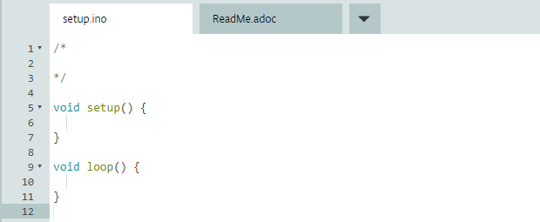

To Students: **Led Pin 13 is on the board. See Diagram.**

Instructor will point to the led on the board. In order to control the pin 8 we have to create a variable in the setup method.

*Have the students initialized a variable called ledPin to the value 13.*

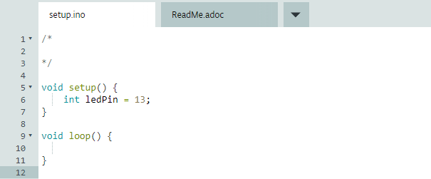

To Students: **The pinMode method provided by the language controls if a pin should be input or output.**

Explain that pinMode takes a number and OUTPUT or INPUT. Input is like putting a quarter into a machine and it outputs a toy. So in Arduino if a pin is OUTPUT that means we are going to output electricity. In a pin is INPUT that means it will receive electricity.

Activity 5: Set the Pin Mode

pinMode(ledPin, OUTPUT);

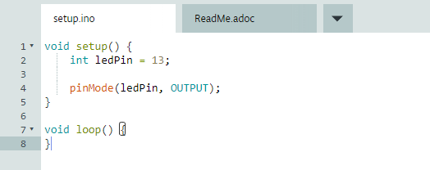

To Students: **The digitalWrite method controls the power of the electricity.**

Instructor will explain LOW means low power and HIGH means high power. If I give it low power that means no electrical current are going to the led and high power means electrical current are going to the led. Explain that HIGH and LOW is like removing a student from the circle.

Activity 6: Send electricity to led 13!

digitalWrite(ledPin, HIGH);

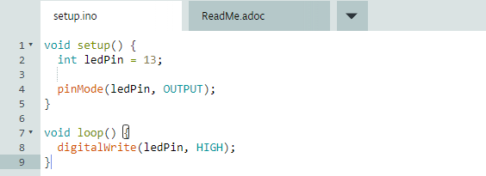

Have the students plug in the Arduino. After loading the code, they should see the led 13 light up.

Activity 7: Make led 13 dark!

To Students: Now try to make ledPin 13 dark!

digitalWrite(ledPin, LOW);

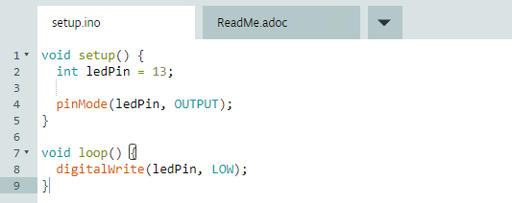

Big Concept #3: Blinking Light

To Students: **When you cross the side walk and there is almost no time left. What is the red hand signal doing?**

Expected Answer: It is blinking!

To Students: **Given that we learned about HIGH and LOW, does anyone have an idea how to make the led blink?**

Let students to discuss several solutions among the group. Give clues like a pause time if needed.

Expected Answer: There needs to be a delay between HIGH and LOW to switch between light on and off.

To Students: **The delay method waits for a certain number of milliseconds.**

Should this method on the board: delay(1000);

To Students: **How many milliseconds are in 1 second?**

Expected Answer: 1000!

Activity 7: Make a led blink

To Students: Now try to make a led blink using pin 8!

Students are expected to wire a led and write the following code on their own at first. If time permits have them write more blinking with different colors.

